
  - MMMM YYYY | Volume 1, Number 1

Club Marketing Plan Template worksheets for membership drives, new fund-raising projects or service programs

No matter what type of project your club undertakes, there must be a plan involved to be successful at your efforts. Sometimes, the plan can be a few paragraphs on a sheet of paper. Other times, the plan takes the form of a small book! This document outlines the steps needed to formulate an actionable marketing plan for a service or fund-raising project and includes spaces for goals and objectives, personnel, marketing and promotion, a timeframe for each part of the program, materials needed, and final critique after the program is over.

For a long-term marketing plan, many of the concepts listed in these pages remain the same. At it’s simplest, you would list your goals for the club and then list the “tools” you would use to achieve those goals. Keep a timeframe and measure your results periodically to determine whether you are on track. Don’t hesitate to ask your district marketing or membership teams for assistance along the way. We have a lot of business professionals on our teams and they are available to help.

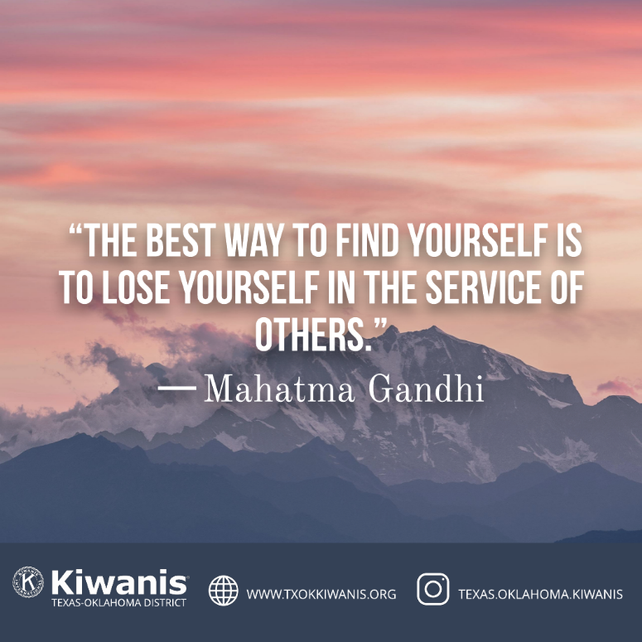

To start off, please list the goals and objectives of the upcoming project. Are you wanting to raise funds? Drive membership? Increase community awareness of Kiwanis programs? Or perhaps provide a worthwhile service project to a part of the community that really needs some help? Keep in mind, it’s possible to get all 4 objectives in a single program…if you have the right plan.
 | Goals & Objectives  1. ___________________________________________________  _____________________________________________________  2. ___________________________________________________  _____________________________________________________  3. ___________________________________________________  _____________________________________________________  4. ___________________________________________________  _____________________________________________________  5. ___________________________________________________  _____________________________________________________  6. ___________________________________________________  _____________________________________________________  7. ___________________________________________________  _____________________________________________________  8. ___________________________________________________  _____________________________________________________  9. ___________________________________________________  _____________________________________________________  10. __________________________________________________  ______________________________________________________
  Using the SMART objective framework, be:
  Specific
  Measurable
  Achievable
  Relevant
  Time based
  
  - Remember, your SLPs need service hours too.
  - Do you have a way for people to donate to your programs with a credit card? Or with their phone?
  - Do you have a realistic deadline to achieve your results?
  - Do you have a Partner, or can you use this activity to develop a new partnership?
  - Your district Marketing and PR team members can help you on your marketing plan.
Here, list all the people who will be participating in the program and their job descriptions. Also, list your individual projects and note whether you will need to find outside assistance or are working with another club or group. More copies of this page may be needed.
 | Personnel, Project, and Job Descriptions  1 ___________________________________________________  _____________________________________________________  2 ___________________________________________________  _____________________________________________________  3 ___________________________________________________  _____________________________________________________  4 ___________________________________________________  _____________________________________________________  5 ___________________________________________________  _____________________________________________________  6 ___________________________________________________  _____________________________________________________  7 ___________________________________________________  _____________________________________________________  8 ___________________________________________________  _____________________________________________________  9 ___________________________________________________  _____________________________________________________  10 __________________________________________________  _____________________________________________________  Make copies of this page if you need more spaces for names
  Find the right people to work each position. If you are short on personnel, consider a joint project with another Kiwanis club or a non-profit with similar goals. Ask your Lt. Gov., Trustee, or District leadership for expertise in a specific area if needed.
  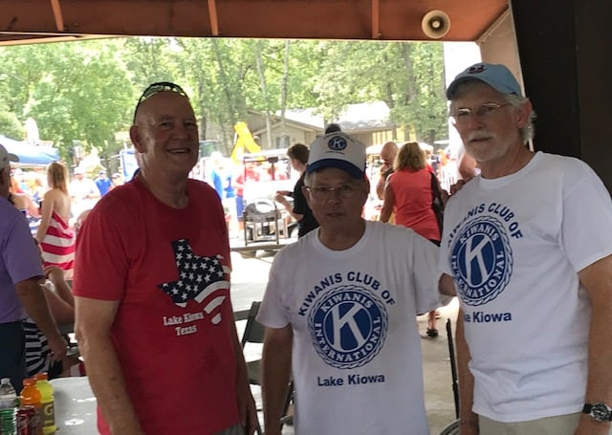
  - Remember your local SLP programs. The kids love to have projects.
  - Here is the perfect opportunity to ask a non-member to participate in a service project. And…they get a job to do! Introduce people to Kiwanis in this way to let them see what we do in the field.
  - Also consider that some members may need training for a specific task therefore adding to the project time frame.
Without a solid Marketing and PR (public relations) plan, the success of a program is in doubt. There needs to be a balanced and studied approach to social and legacy media to get the best result for the hours put into the advertising campaign. If in doubt about social media, ask a Key Clubber to help. Or, contact the district Marketing and PR teams. Below, check off the programs you plan to use or plan to improve.
 | Marketing/Promotion  1. Website -is it updated and ready to use?  2. Club Facebook page. A “must” for almost every project  3. Community Facebook pages – usually reaches thousands of additional people for free. Apply to the page for editor status.  4. Instagram – reaches a younger crowd who probably don’t have a Facebook page. Worth the effort. Requires updates by phone.  5. Twitter – A good platform for letting the media know what the club is doing. Lots of journalists have Twitter Accounts  6. Legacy news – contact your local newspaper and town magazine and introduce your club. Send press releases about your upcoming programs. In some markets, Radio is great.  7. Business cards, post cards, brochures – these are very handy tools to hand out at events and BEFORE events at chamber meetings, business network meetings, and to businesses in town.  8. Email campaigns – Use Mail Chimp to help your club build a professional email campaign. Allow people to opt into the campaign via your website and Facebook pages. Also collect email addresses from guests and member contacts.  9 “Next door” or “Neighborhood” apps. Digital news from your neighborhood and a great way to let your neighbors know about upcoming Kiwanis events. Do a search on your computer or phone for the app that includes your local neighborhood.  10 Audio and Visual – People respond to video news. Use your phone to take short 20 second videos to post on Facebook and Instagram and then create an account on YouTube to store these and share.
  Next to having popular fund-raisers and service projects, your club’s marketing program is key to successful club growth. People want to join a winning team. But, they need to hear about you first. Try some different methods of promotion.
  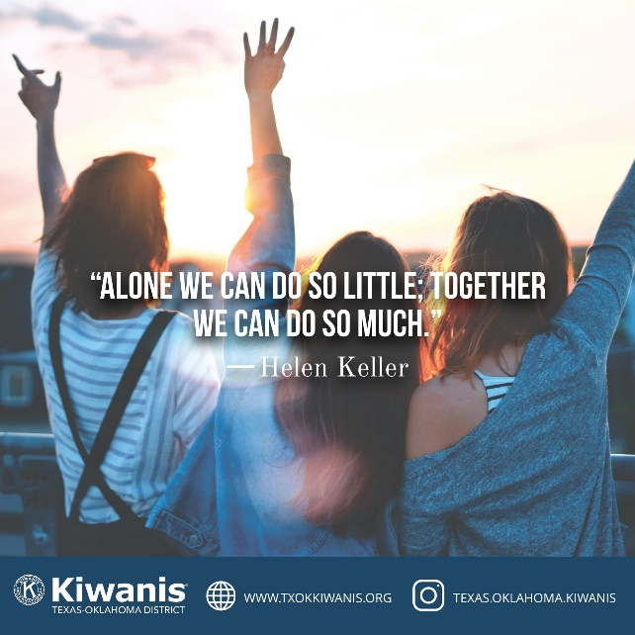
  - Kiwanis has a partnership with Office Depot and provides a discount on printing.
  - You can get ready-made videos and audio at www.Kiwanis.org/brand if you want to promote the club at any time.
  - There are dozens of additional ways to successfully market your club. These ideas listed here are some of the “Biggies”.
 | Grading your plan’s results  Grade your performance on the project in order to make adjustments for future efforts.  1. Did you meet all of your goals and objectives?  2. Was each part of the project completed in the allotted time?  3. Did you get the publicity that you were hoping for? Did you get any media attention for your program?  4. How about funds? If you were working on fund-raising, was the effort successful?  5. Were you able to hand out membership material and get any interest from potential new members?  Make some notes below and include recommendations for upcoming events. Having a written record of your results is a goldmine for future planning.
  The end of the event, and the critique of its success, is just as important as any other part of the program. Did your club achieve it’s goals, as stated on the 1st page of this marketing plan, or did some part of the plan fall short? What areas were problematic? What would you do differently, if anything, in the future? Grade your efforts and keep this page for future reference.
  
  Write your notes here regarding the success of your program and any areas that need improvement.
There is a lot of program support that is needed to make a Service, Fund-raiser, or Membership drive successful. What will your club need in order to enhance it’s professionalism and visibility? Below right are listed some product ideas. Make a note of what your club needs and contact district HQ for assistance if needed. Below, check off the programs you plan to use or would like assistance with.
 | Material Support  1. Membership applications can be ordered through Kiwanis International at Kiwanis.org. Go to shop Kiwanis. An on-line application to email to your prospect can be found at txokkiwanis.org under member resources.  2. Zoom training sessions for membership or marketing  3. T-Shirts, flags, pins, etc. We have our own Kiwanis certified vendor in our district. We can supply almost anything with a Kiwanis logo.  4. Press releases, artwork, posters, billboard designs, business card design, etc.  5. Sponsor, Member, and Partner decals can be ordered from District Marketing Chair. (Call for price) Corporate brochures that can be handed to businesses explaining the advantages of supporting the local Kiwanis club can be ordered from International at shop Kiwanis.  6. Do you need a club coach to assist with club strengthening? We have trained club coaches in every part of the district. Contact Membership Chair if so  7. The District has lots of membership material in Spanish if needed. See our website under member resources  8. Coloring books for kids. We have coloring books that show Kiwanis activities in them. Very cool and very popular. These come in English or Spanish and can be ordered from HQ.  9. Does the club need any help revitalizing the club website or Facebook page, or creating any other social media accounts?  10. Assistance with establishing credit card accounts for the club, as well as cash apps like Venmo and Zelle, plus customized QR codes for your marketing material.
  The district and Kiwanis International have lots of material available to help your club be a success at whatever program you choose to pursue.
  Contact your district marketing team if you need help in attaining any of the items listed to the right.
  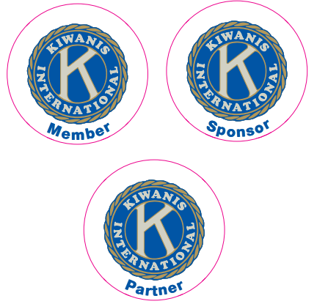
  - Kiwanis supports clubs in the district by providing professional material that positively impact the opinions of people in the community.
  - Club coaches are Kiwanis volunteers who have taken additional training in order to help clubs be their best.

Creating a timeframe for a project has multiple reasons. First, it organizes each of the program parts so that all pieces come together at the same time, on time. Second, it helps people meet their individual goals and responsibilities. Third, it helps the entire team visualize where they are at any given time during the project. Use the various Date columns if you have milestones along the way that must be met. Otherwise, just leave them blank.

Timeframe for Project

Enter names or parts of project Date 1 Date 2 Date 3 Date 4 Completion

Make a copy of this page if you need more rows to the table.

This club marketing plan template created by Marshall Kregel, Marketing Director for Tx Ok Kiwanis, Jan. 2022
For assistance, contact him at mkregel@hotmail.com

