


What is Women in Kiwanis (WIK) Assistance Fund? This fund was started by Governor Susan Hennum in 2011/2012 during the 25 years of Women in Kiwanis celebration to address the need for undesignated monies to be used for leadership conferences for our students. It is to be either matching or partial payments for our SLP students to attend leadership conferences. This scholarship was approved by the 2011/2012 Foundation Board.
Who Can Apply For The Funds? Must be a student and a member of Key Club or CKI.
Where Did the Funds To Endow This Come From? The fund initially received monies as being the “official benefactor” for Governor Hennum during her year. Also T-shirts, bags and awards were designed to raise awareness of 25 years of women in Kiwanis. All proceeds from these sales were donated to this Fund. This program also received some income from Governor Wilkins and then in 2014/2015, Governor Colleen Biggerstaff once again made it a major platform. We are excited to announce that 2023/2024 Governor Dr. Kathy Culbertson has also chosen to highlight Women in Kiwanis.
Why Should Clubs Donate? Many students miss out on the District Convention learning experience because they cannot afford the cast. The WIK fund is meant to be “assistance” for the student. Students applying for assistance need to be such that without these monies they would not be able to attend an event. There must be a need to receive funds. A letter of request for funding for this student must come from either Faculty or Kiwanis advisor. This letter will accompany the application for assistance.
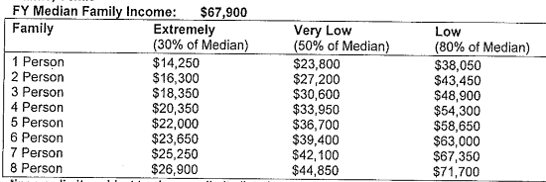
How much can someone request? This grant is intended to be an assistance, not a complete funding vehicle. The student needs to be responsible for anywhere from 30% to 50% of the cost.
Who Decides? This amount is to be determined by a committee of 5 individuals appointed by the President of the Texas Oklahoma District Foundation. This committee will review the application and make funds available payable directly to the event.
How Does Someone Apply? Applications for assistance can be obtained on the Foundation website after October 1, 2023.
Funds Available Funds available each year are based on the amount collected and endowed.

Conditions
Students can apply for one scholarship per year.
Funding is paid directly to the event

Anyone receiving funding and then not attending the event will be responsible to pay back the scholarship fund any monies that were paid out in the name of the student. This funding is for leadership events and funding per student is not to exceed $200.

